

EE462 & EE464 Project: Design of a SM-PMSM Variable Frequency Drive with Matlab/Simulink

Hakkı GÜLCÜ

Tel: +90 534 397 29 66

mail: [hakkigulcu35@gmail.com](mailto:hakkigulcu35@gmail.com)

2093862

Özgür

Tel: +90 535 938 69 20

mail: [ozgur_6155@hotmail.com](mailto:ozgur_6155@hotmail.com)

2093805

**Supervisor:** Ozan KEYSAN & Emine BOSTANCI

Date of Submission: 02.06.2019

# Introduction

The aim of project is to design a SM-PMSM Variable Frequency Drive with respect to given parameters below by using matlab Simulink program.

𝑃𝑛𝑜𝑚𝑖𝑛𝑎𝑙 = 80 𝑘𝑊

T𝑛𝑜𝑚𝑖𝑛𝑎𝑙 = 300 𝑁𝑚

𝑛𝑚𝑎𝑥 = 7000 𝑟𝑝𝑚

Pole number: p=8

𝐹𝑙𝑢𝑥 𝑙𝑖𝑛𝑘𝑎𝑔𝑒: 𝜆𝑃𝑀 = 0.2 Vs (Wb-t)

𝐿𝑑 = 𝐿𝑞 = 500 uH

𝐼𝑛𝑜𝑚𝑖𝑛𝑎𝑙 = 250 𝐴 (peak)

Phase resistance 𝑅𝑠 = 50 mOhm

Equivalent inertia of the system: 𝐽𝑒𝑞 = 10 kg m2

Ignore windage and friction losses.

The available supply is a three-phase AC source (50 Hz, 400Vl-l) and the PM is a surface-mount motor. Assume a 3-phase full-bridge diode rectifier is connected to the grid.

# Part A: Pre-design Stage

## Calculation of the rated speed and torque of the PMSM.

$$Wbase=\frac{Pnominal}{Tnominal}=\frac{80 kW}{300 Nml}= 266.67 rad/sec , Nbase=2546.48$$

$$T=\frac{3}{2}*pp* λPM*iq Where nomimal base Torque condition, İq=İnominal =250 A , İd=0$$

Then T=1.5*4(pp)*0.2*250 = 300Nm where it is also given in parameters.

## Calculation of the maximum applied electrical frequency and choose a switching frequency for your inverter

$$We=2*π*f , then frequency=\frac{We}{2*π}$$

$$where from part a We(max)= \frac{7000rpm*2*π}{180} is found 733 rad/sec,$$

$$fmax=\frac{733}{2*π}=116.67 Hz$$

Selected Switch frequency=10kHz

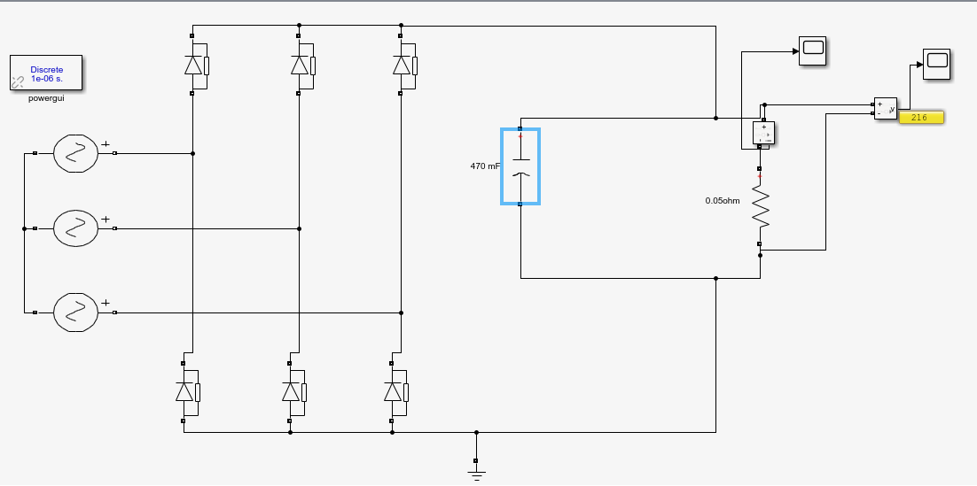

Figure :Design of DC-link filter for the rectifier block

We select the capacitor as 100 mF in order to decreases the voltage ripple.

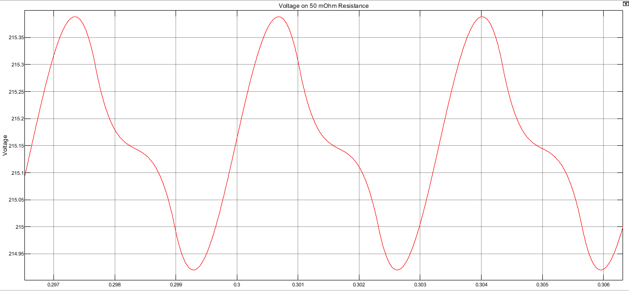

Figure : Plot of the DC-link voltage waveform by connecting a resistive load equivalent to motor.

As seen figure 2. Voltage ripple is about 0.4 V. Avarage DC-link voltage as 215.15 .

Then, Ripple = 100 $\frac{0.4}{215.15}=\%0.2$* , This is so efficient result for our design.

# Part B: SPWM Design

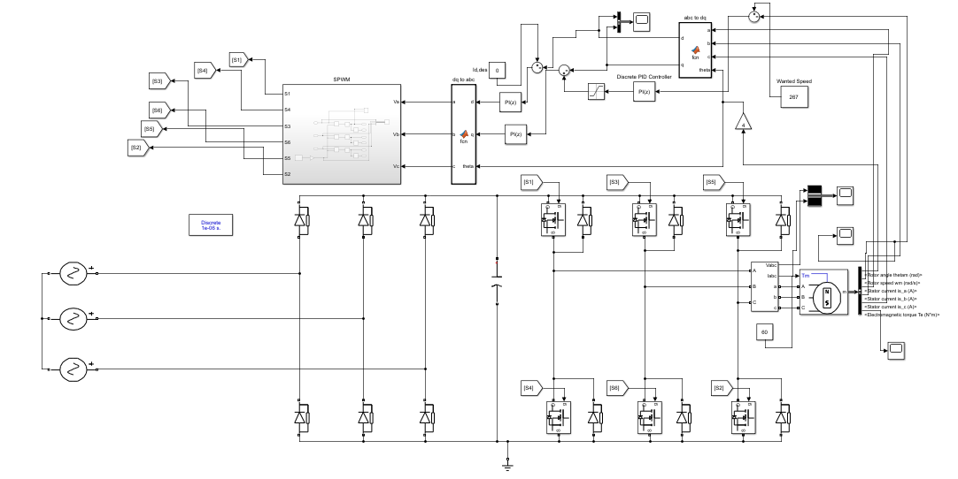

Figure 3. Overall System

1. Graphs are given below;

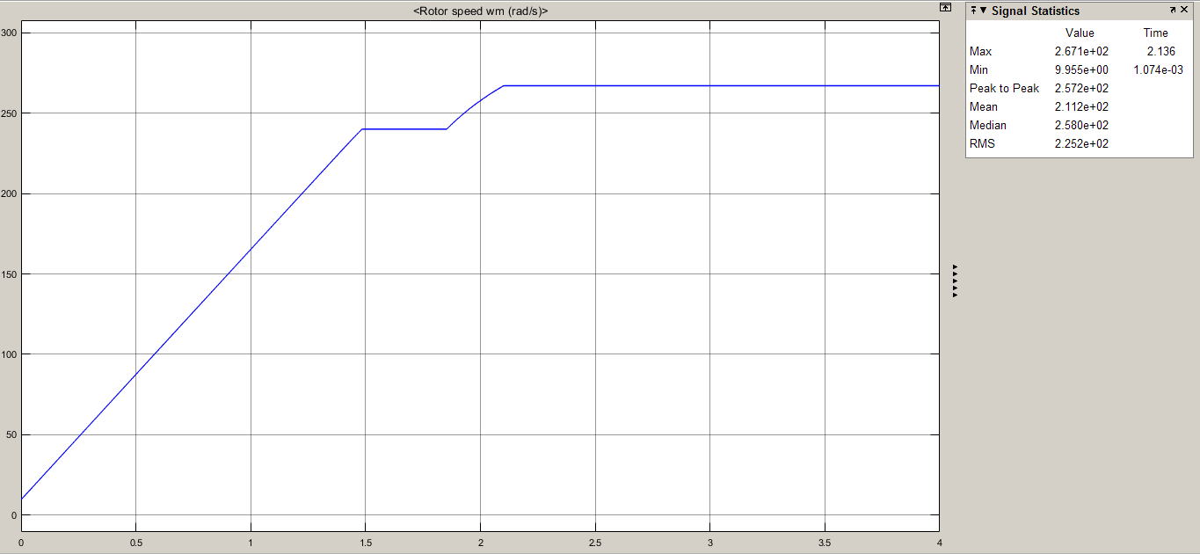

Figure 4. 90% Rated Speed(240 rad/s) to Rated Speed

We had given 240 rad/s first to the reference speed and reach that value and after some milliseconds, we made the ref speed rated speed.

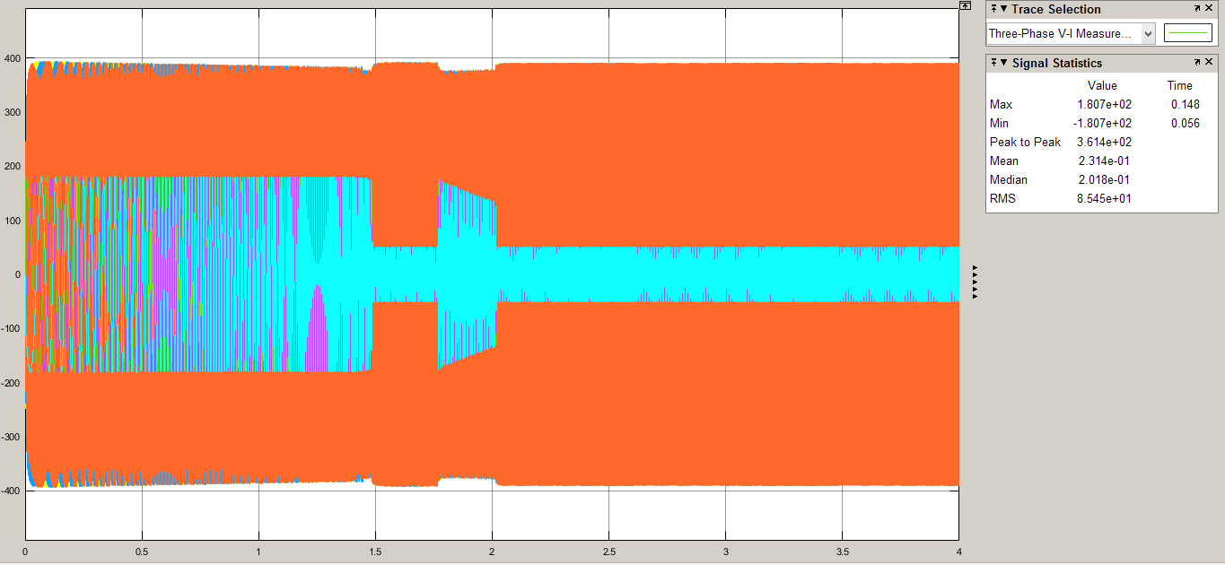

Figure .Vl-l and Iph Waveforms

The phase current is around 180 Apeak until the speed is stable at wanted speed. Then at stable condition, Iph ,peak = 40-50 A,peak. Vl-l does not differ much around the time of stable and switching sequences.

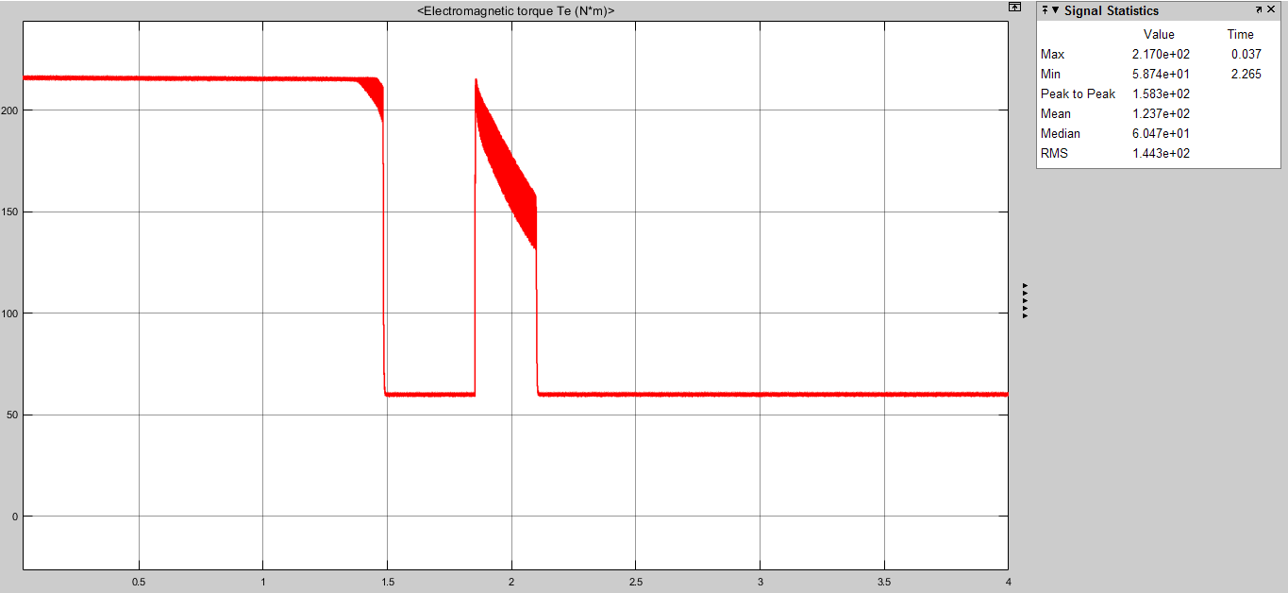

Figure 6. Torque vs. Time

Torque is around 220 Nm at the operation of transient time and then decreases to 60 Nm.

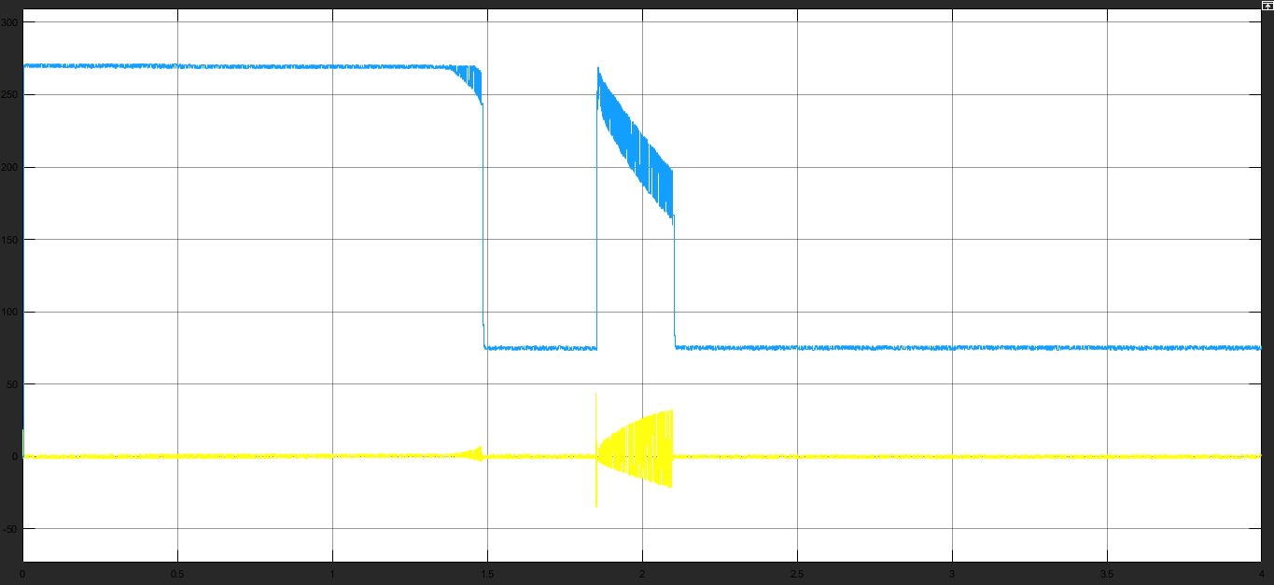

Figure 7. Iq(blue) and Id(yellow) Waveforms

Notice how Iq waveform is similar to Torque waveform and also observe how id changes and oscillates around the rated speed and id begins to be a non-zero value.

1. Load is unloaded around t = 1.9 sec;

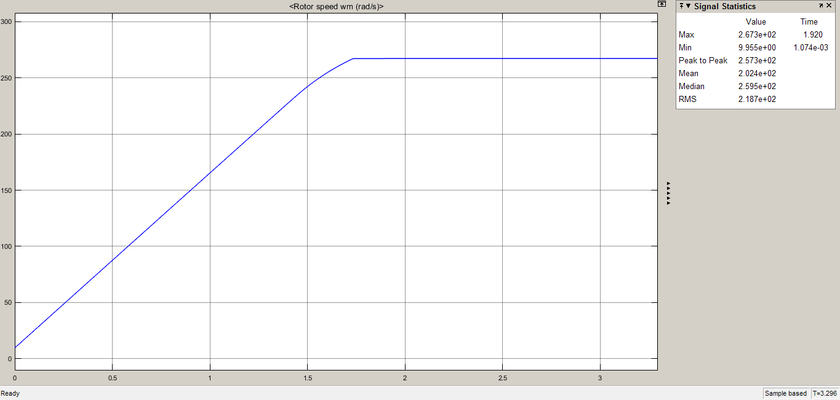

Figure 8. Speed vs. Time

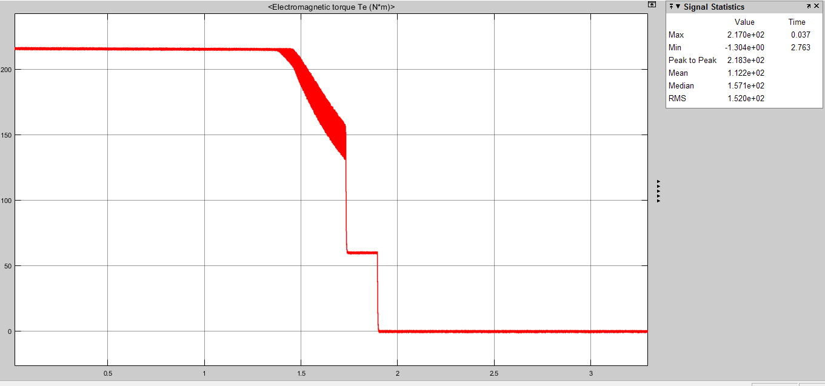

Figure 9. Torque vs. Time

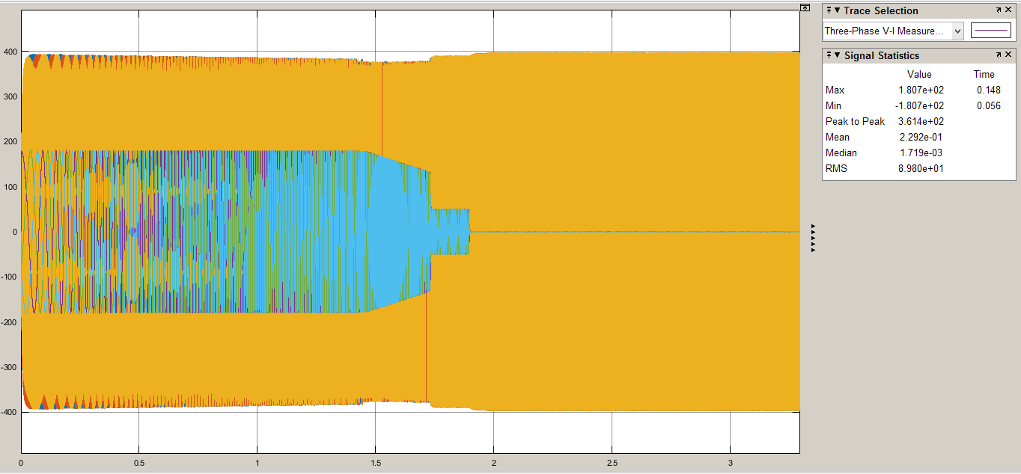

Figure 10. Iph and Vl-l

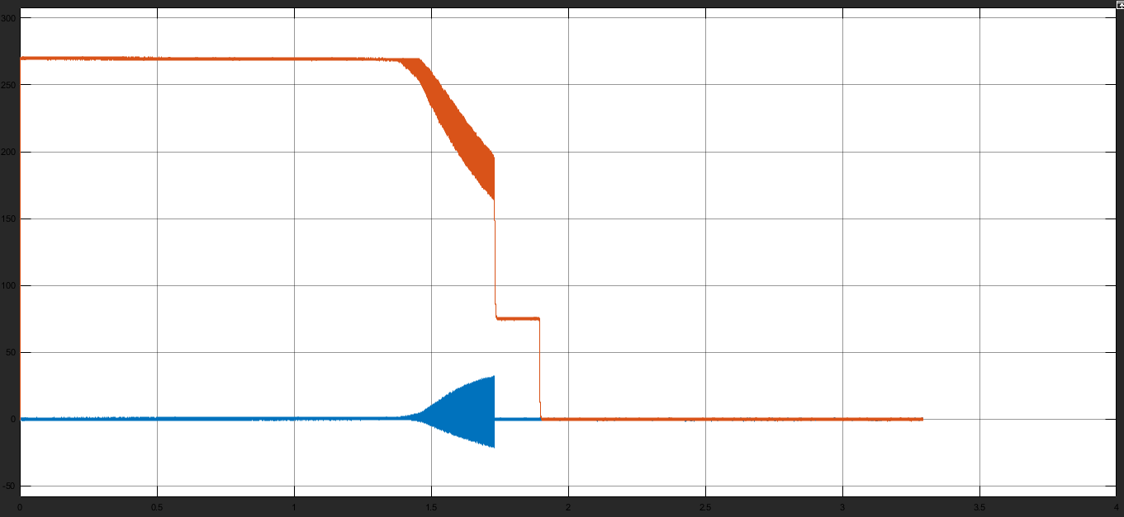

Figure 11. Iq and Id

According to these figures, motor speed stays the same after the system is unloaded but Id and Iq values, Iph and also Torque of the system decreases to zero.

**3)**

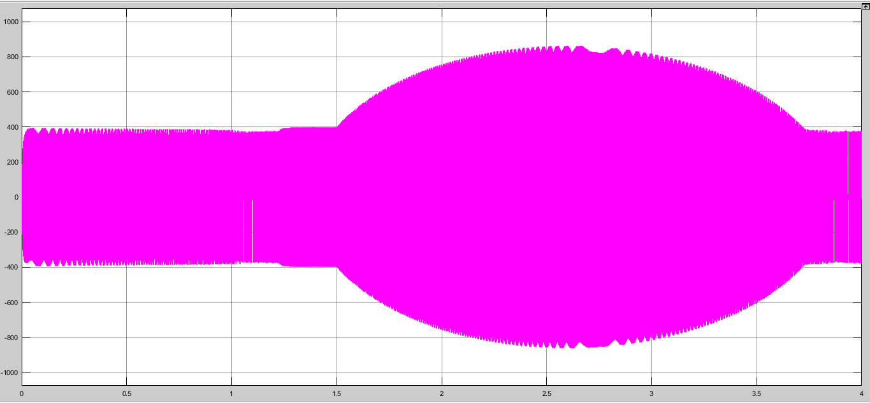

Figure 12. Vl-l Waveform

As it can be seen here, line to line voltage value increases over 800 Volts,peak and this can be dangerous.

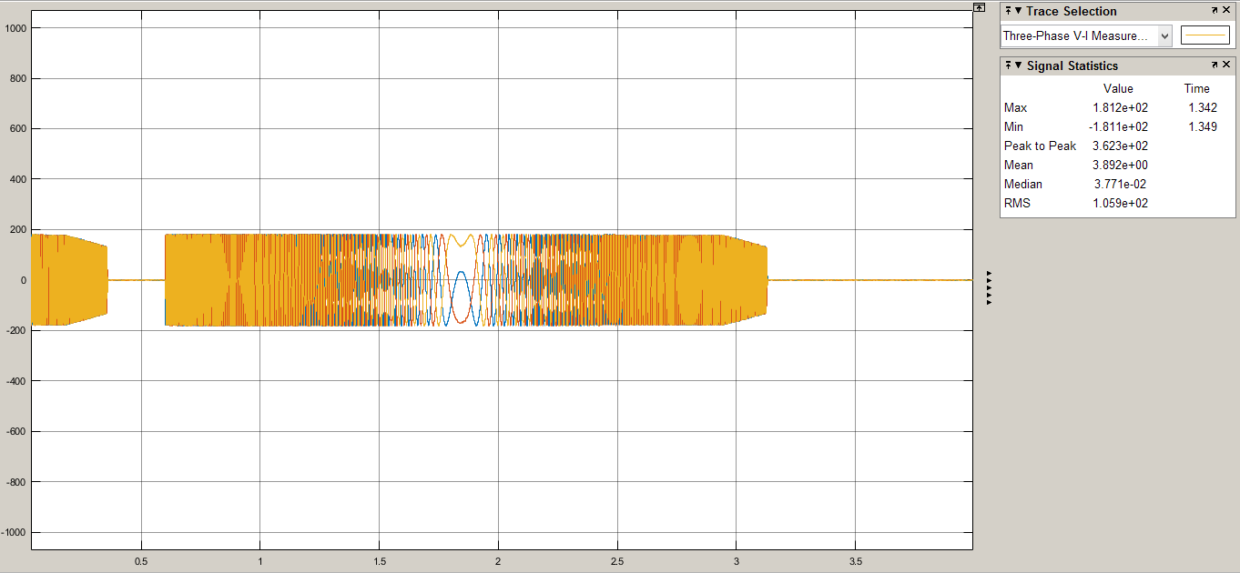

Figure 13. Iphase vs. Time

Irms = 127 Arms;

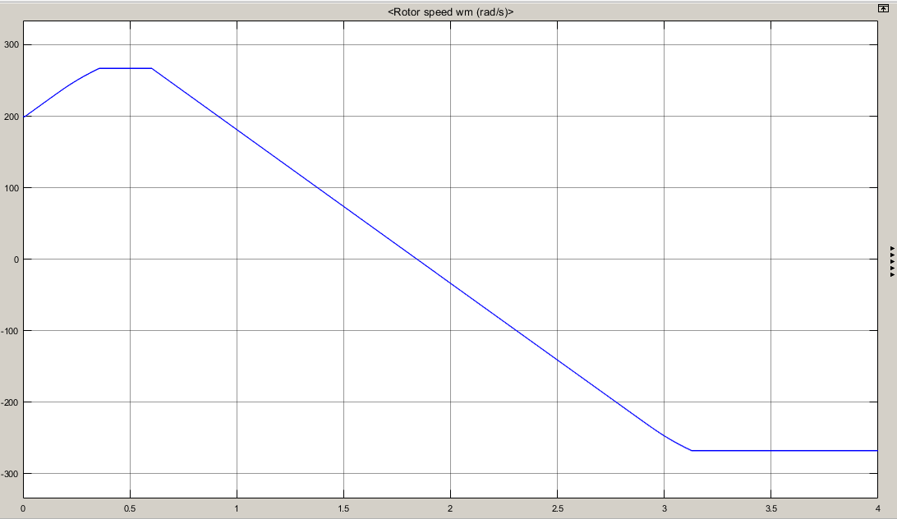

Figure 14. Speed vs. Time

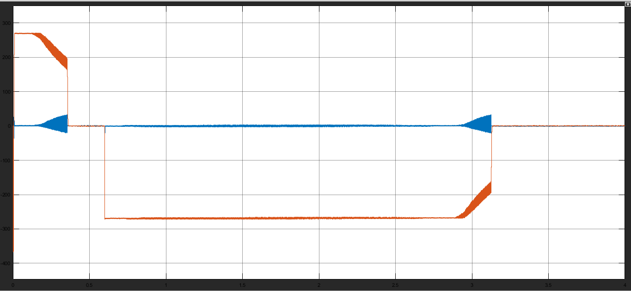

Figure 15. Iq and Id Currents

When the speed of the motor decreases to zero in inverse speed operation,

**4)**

We must use field weakening here to lower the K*flux value because in this region motor’s power is constant and in order to change increase the speed, we must lower the K*flux value.

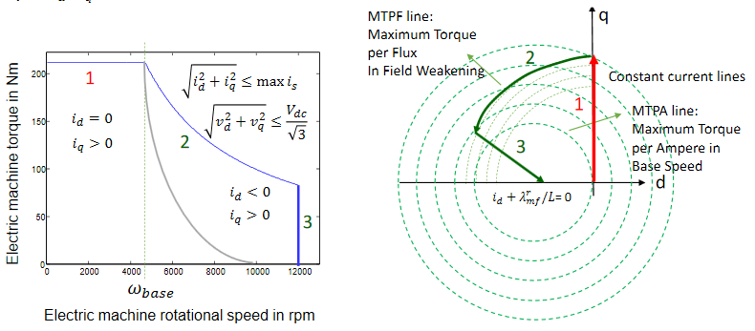

Figure 16. Torque vs. Speed and q-d Coordinates for the Motor Operation

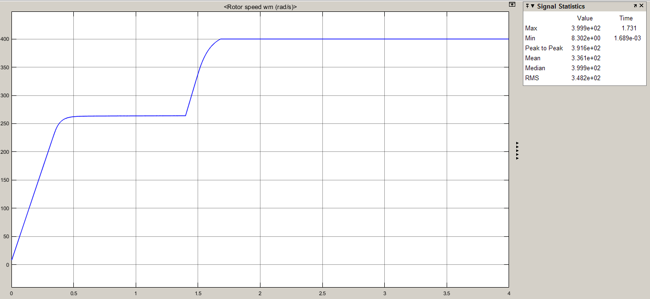

Figure 17. Speed of the Motor after the Controller Operation

In order to get into the field weakening mode, we need to increase the Id value. We observed that when we get the value of the Id to -300, we go straight to 400 rad/s which is 150% rated speed of the motor.

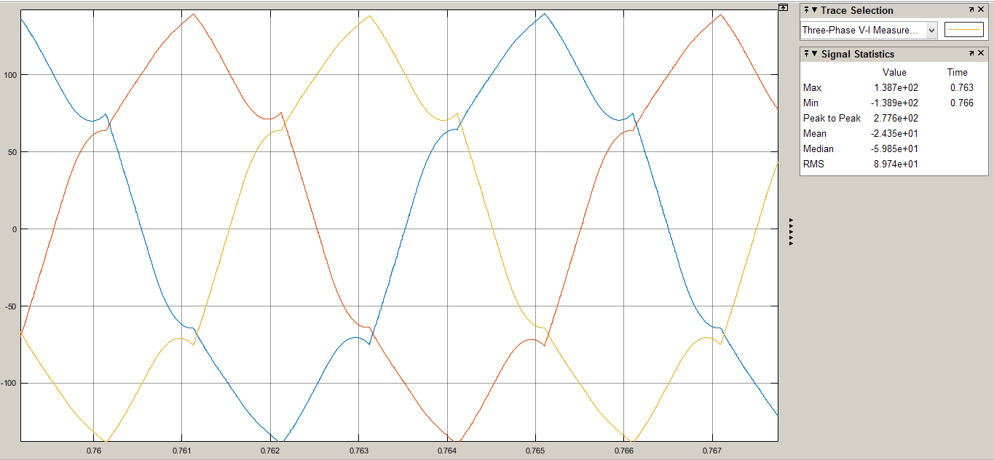

Figure 18. 3-Phase Current When at Rated Speed

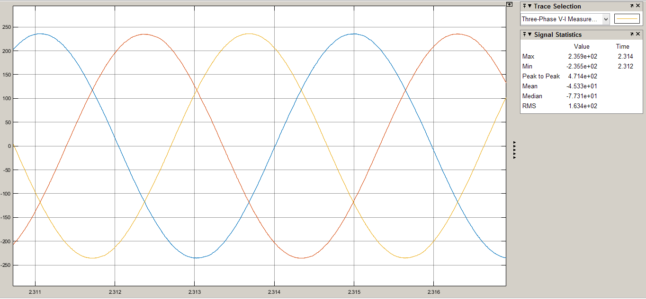

Figure 19. Iphase when at 150% Rated Speed

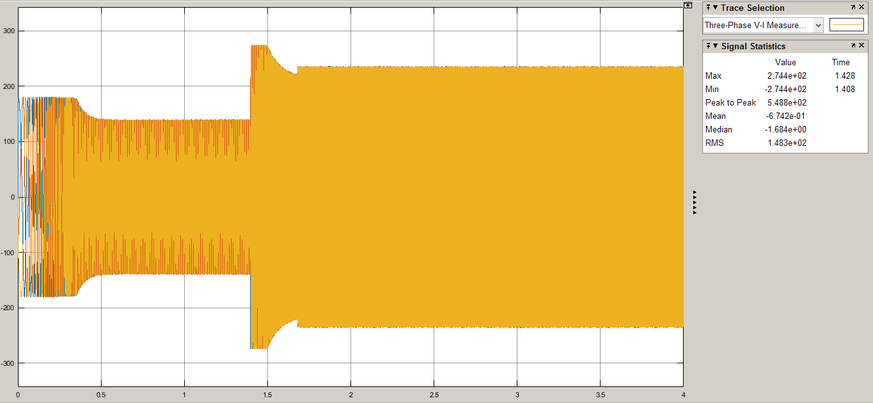

Figure . 3-Phase Current Waveforms

As it can be seen from the Figure 19, Iphase,peak = 236 Apeak which is below rated current.